Bio/Allied Magnet Information
Summer 2018

I. Graduation Requirements
The Institute for Health Sciences at Ridge View High School was established in August, 2008. The program consists of two magnets: BioHealth Sciences Magnet and Allied Health Sciences Magnet. The graduation requirements for each program are as follow:
BioHealth Sciences Magnet Graduation Requirements
- All math and science courses must be completed at the honors level. A minimum of four Advanced Placement (AP) or University of South Carolina courses must be completed by graduation. These four AP courses must consist of at least one math, two science, and one other AP course.
- Successful completion of all PLTW courses at the honors level (Principles of Biomedical Sciences, Human Body Systems, Medical Interventions, Biomedical Innovations),
- Conduct a research project and present results in oral and written form,
- Complete a 2-week internship in the student’s area of interest,
- Actively participate in at least two major field studies, and
- Successfully complete an electronic portfolio of the student’s work throughout this four-year program.
All these requirements must be met in order to receive a Richland School District Two BioHealth Sciences Magnet Diploma.
Allied Health Sciences Magnet Graduation Requirements
- All math and science courses must be completed at least at the college preparatory level.
- Successful completion of all PLTW courses at the honors or college preparatory level (Principles of Biomedical Sciences, Human Body Systems, Medical Interventions, Biomedical Innovations),
- Conduct a research project and present results in oral and written form,
- Complete a 2-week internship in the student’s area of interest,
- Actively participate in at least two major field studies, and
- Successfully complete an electronic portfolio of the student’s work throughout this four-year program.
All these requirements must be met in order to receive a Richland School District Two Allied Health Sciences Magnet Diploma.

AP Language and Composition:
Task 1: You will read Between the World and Me (Coates) and Kid Kustomers. Students are expected to read and take notes on all listed books and essays. Complete the notecard assignment (attached) so you are prepared for class discussions and assessments when school begins Wednesday, August 22, 2018. Honors and AP students are encouraged to purchase copies of books and to highlight and/or annotate significant passages as they read

Task 2: Select one novel from the list on the next page and read the novel. Complete the notecard assignment (attached) by August 22, 2018.

Honors English 3:
Task 1: Students are expected to read The Great Gatsby (Fitzgerald) and complete the notecard assignment (attached) so you are prepared for class discussions and assessments when school begins Wednesday, August 22, 2018. Honors and AP students are encouraged to purchase copies of books and to highlight and/or annotate significant passages as they read

Task 2: Select one novel from the list on the next page and read the novel. Complete the notecard assignment (attached) by August 22, 2018.

English 3 CP:
Task1: Select one novel from the list on the next page and read the novel. Complete the notecard assignment (attached) by August 22, 2018.

Our summer reading program requires that, all students, including honors and AP students, select and read one book from the list below, and actively participate in discussions and other engaging activities with your book group during our Summer Reading Celebration Day. This does not fulfill any class requirements and participation is not graded. If you have any questions, please contact Ashley Walker (aswalker@richland2.org). Rising 9th grade students will be asked what book you read after school begins in August.

- Black Panther: A Nation Under Our Feet Book 1 by Ta-Nehisi Coates and Brian Stelfreeze
- Every Day by David Levithan
- The Beginning of Everything by Robyn Schneider
- One of Us is Lying by Karen M. McManus
- The Hate U Give by Angie Thomas
- Dear Martin by Nic Stone
- Long Way Down by Jason Reynolds
- Violent Ends by Shaun David Hutchinson
- Sunrise Over Fallujah by Walter Dean Myers
- A Wrinkle in Time by Madeleine L'Engle
- Fahrenheit 451 by Ray Bradbury
- Girl Code: Gaming, Going Viral, and Getting It Done by Andrea Gonzales and Sophie Houser

Institute for Health Sciences
5” x 8” Note Card Assignment

- Format your card to make the information easy to read and to review.
- Do not plagiarize from online sources or from your classmates. This information will only resonate with you if it comes out of your own brain. If you haven’t read the book, then either read it or don’t expect to receive credit for assignments on it.

On side 1:

1. title and author/time period in which it was written

2. Major characters with appropriate labels: protagonist, foil, antagonist, etc.

3. For a novel, include point of view (be specific)

4. setting (specific time(s) and place(s));

5. irony (2 examples, with brief explanation)

6..symbols (cite 2, with brief explanation)

7. themes—write 2 (write as a statement); brief evidence to support

8. explanation of title

9. memorable quotations relating to character or theme: cite 2. Provide the speaker and the significance.

10. Cite two examples of medical ethics issues. Justify from your reading why you think each example presents an ethical consideration.

On side 2:

Plot--use the back of the card only, recording key episodes. This objective paragraph summary (no commentary) should be about 175+ words

Notecard Assignment Exemplar:
Front:
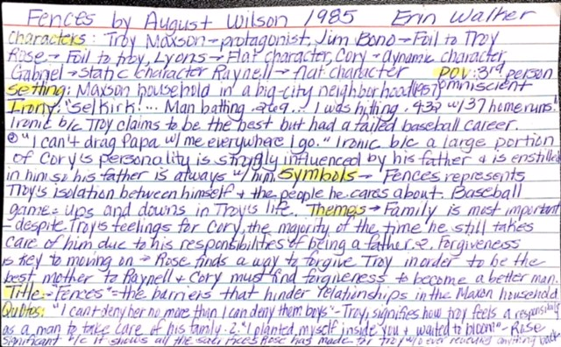
Back:
: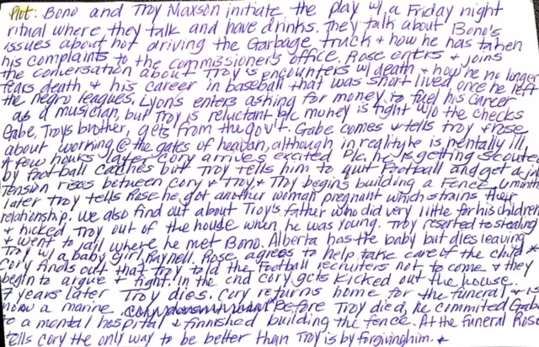

STEM Premier (Resume)
- Log in to your STEM Premier account and add Mrs. McLeod as a mentor using the profile tab.
- Update the following sections:
  - General Info
  - Education
  - Next Steps
  - Career Interest
  - Skills
  - Pathways
  - Activities- including volunteer experience and extracurricular activities

The following sections must be completed no later than Wednesday, August 22, 2018.
Research Project (Due August 27, 2018)
- Initial Step
  - Log in to the Google Classroom: Magnet Senior Research Resources (CODE is: edbrhsb)
  - Read the Developing a Research Topic Presentation
  - Research three topics of interest in the math or science fields.
    - What are you interested in? Think big to start and then narrow your topic.
    - What research is currently being conducted? (Look for three primary resources for each topic)
- Proposal
  - Use the Research proposal template to begin the research process for your three areas of interest.
  - Make a hard copy of three primary sources for each of the three proposals.
  - Read and annotate the primary resources.
  - Complete the research proposal following the rubric for each of the three topics.
  - Three primary sources for each topic (printed and annotated) and the research proposals are due August 28, 2018

***Remember the Google Classroom has examples and tips to help you through the process. If you have questions, please email, Mrs. McLeod or Dr. Degenhardt.

Research Proposal Rubric

Name ____________________________________ Date ________________________

Title __________________________________________________________________________________

_____(1) Title (if cause effect problem, should describe the effect of the IV on the DV, but this is not
essential for all papers)

_____ (3) General introduction to topic

_____ (3) Background information on Independent Variable

_____ (3)Background information on Dependent Variable

_____ (3)Previous research with citations or
detailed development of problem through literature with citations

_____(3) Purpose statement with rationale (clearly stated)

_____(3) Hypothesis statement (clearly defined in terms of measurable effect of IV on the DV)

_____ (3) Brief statement summarizing method

_____ (1) In text citations--APA format

_____(1) On-time, typed, double spaced

_____(3) Overall effort****

_____ Total (27)

****Includes…
-succinct sentence structure (lots of relevant content, not lots of words).
-statements of fact in active voice and present tense.
-writing concerning research, including purpose, rationale, hypothesis, and method statement in third person, past tense, passive voice.

As of now you have not yet done your experimentation. However, you should write in past tense like you already did . This is because your final paper tells about what you did, not about what you are going to do. This is the first part of your final paper.

